# Programming Fundamentals:

Lab Task#6:

Question # 1:

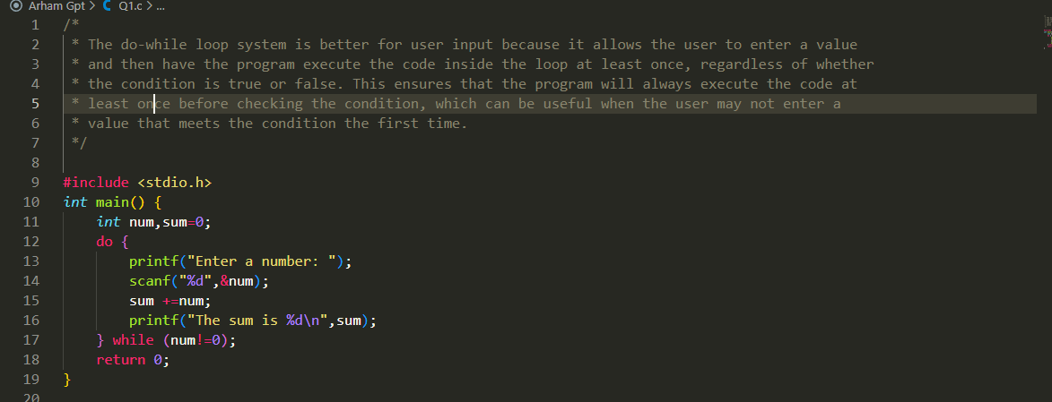

Question #2:

Question # 3:

Question # 4:

Question # 5:

Question # 6:

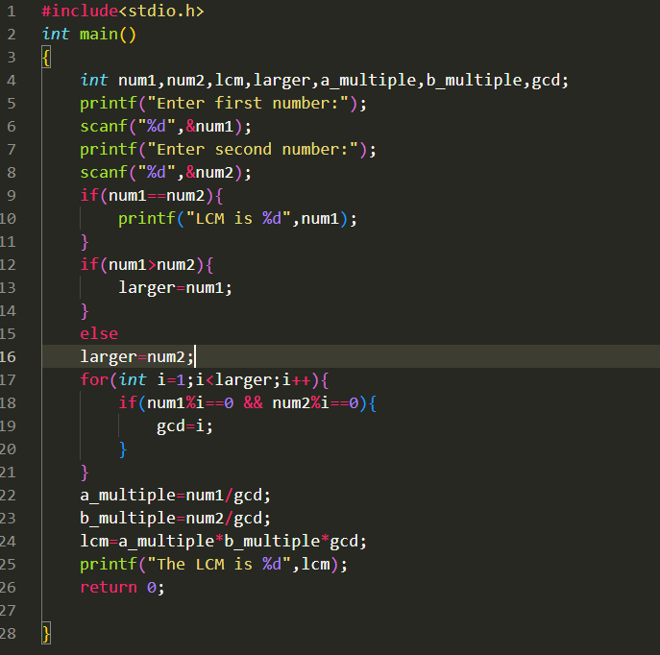

Question # 7:



